- S8002 Strategyf
- Before plan
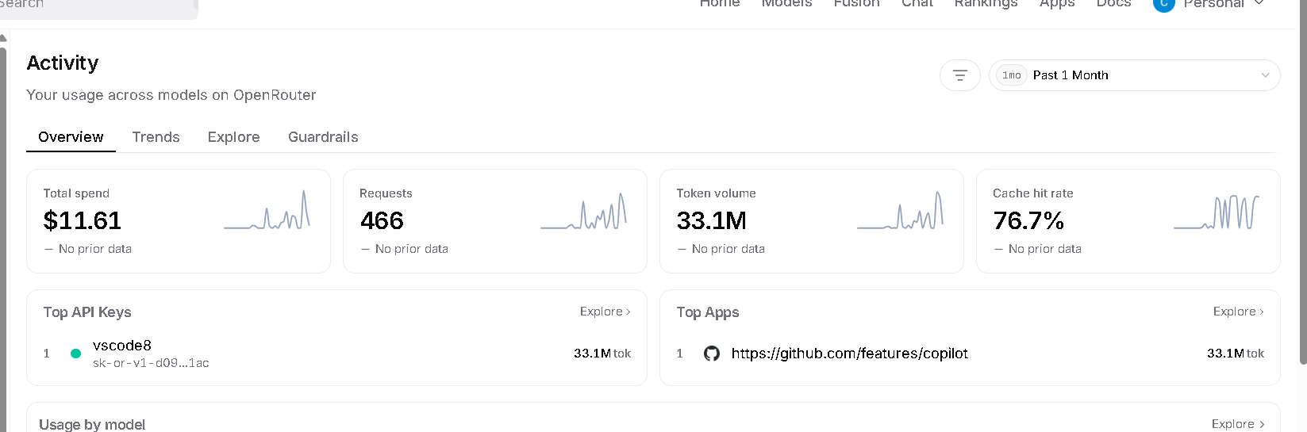
- After plan, before agent implement
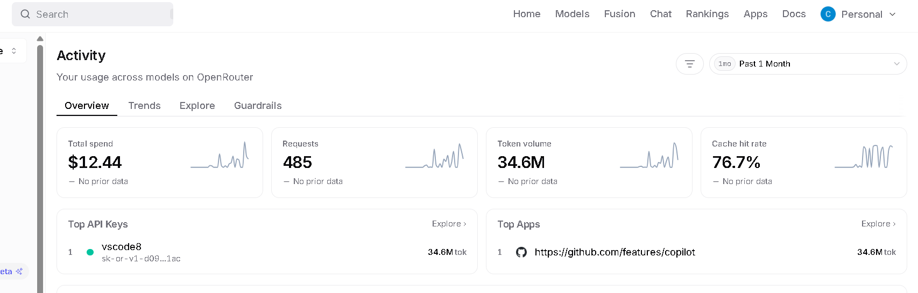
- After agent implement
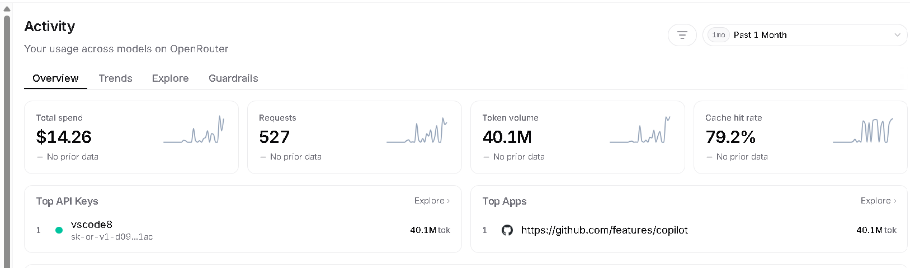
- End

